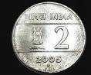
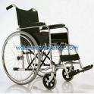
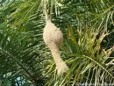
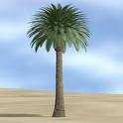
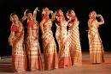

Class IV
Kendriya Vidyalaya IIT Chennai – 36
Model paper 3 - EVS

Part A

Time – 2 hours

I.Observe the pictures and answer the following :
In which country can you use this coin ?
_ ________________________________________________

People who cannot use their legs use this.
_____________________________________________

The bird makes beautiful nests for its partner.
__________________________________________
A common desert tree which looks like the coconut tree
____________________________________________

The dress worn by the assamese woman:
___________________________________

II. Answer the following:
1. Compare the characteristics of animals that give birth to young one and those that lay eggs.
_____________________________________________________________________________________
_____________________________________________________
2.Write two duties performed by the doctor on a naval ship.
_____________________________________________________________________________________
_____________________________________________________

3.What are the functions of the roots.?
_____________________________________________________________________________________
_____________________________________________________

4. If you get a chance to go to Abu Dhabi what are the things you will get to see ?
_____________________________________________________________________________________
_____________________________________________________

5. What do you understand by these terms?
a) Prism : ______________________________________________________________
b) Sand dunes __________________________________________________________
________________________________________________________________________
Part B
I. Match the following :
a) Team Game _______________ Bishnoi
b) Amritha _______________ Kabaddi
c) Karnam Malleshwari _______________ Handloom
d) Gandhiji ________________ Weight lifter

II. Answer the following :
1. What are the materials used to build a bridge ? Draw a bridge (of your choice )
_____________________________________________________________________________________
_____________________________________________________________________________________
2. Why do we add spices to food ? Name any two spices.
_____________________________________________________________________________________
_____________________________________________________________________________________
3. If you are going on a long journey by train, what are the things you should remember to carry along ?

_____________________________________________________________________________________
_____________________________________________________________________________________

III. Write about Bihu festival OR Write the various steps involved in the making of
Pochampalli sarees.
_____________________________________________________________________________________
_____________________________________________________________________________________
_____________________________________________________________________________________
Part C
I. Draw
1. A tree with hanging roots and name it.
2. An animal with no ears and name it.
II Answer the following
1. Name any two flowers that grow in water and draw any one
_____________________________________________________________________________________
_____________________________________________________________________________________
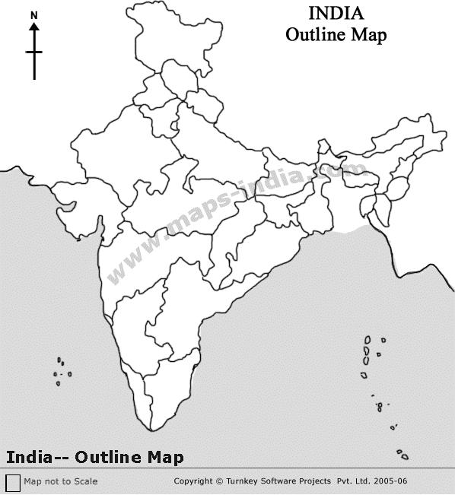
2. Write any two uses of pulleys
_____________________________________________________________________________________
_____________________________________________________________________________________
3. Give reasons for why :
a) Very few trees grow in the desert.
_____________________________________________________________________________________
_____________________________________________________________________________________
b) We should not drink contaminated water
_____________________________________________________________________________________
_____________________________________________________________________________________
III. Identify the states and mark on the given outline map:
1. Wahida belongs to this state : ____________________
2. Anita belongs to this state : _____________________
3. The state we live in : _____________________
4. Nandita belongs to this state: _____________________
5. Where Pochampalli district is: ____________________

Class IV
Kendriya Vidyalaya IIT Chennai -36
Model paper – 3 EVS Answer keys
Part A

I. Observe the pictures 5 x 1 = 5
1. These coins can be used in India.
2.This is a wheelchair used by people who cannot use their legs.
3. This is a weaver bird’s nests.
4. This is date palm tree found in deserts.
5.The dress worn by Assamese women is mekhala chador.
II Answer the following : 5 x 2 = 10
1. Animals that

Give birth to young ones
lay eggs

1. Ears can be seen Ears cannot be seen
2. Have hair on skin Have feathers on skin
2. The doctor on a naval ship makes sure that everybody on the ship stays fit and healthy.
She carries out medical check-ups of all the officers and sailors
She checks if cleanliness is maintained on the ship.
She trains everybody to get ready for any medical emergency. ( any 2)
3 .Functions of the root in a plant:
The root lies under the soil. The root bear thread like roots called root hairs.
It fixes a plant to the soil, helps in absorbing water and minerals from it.
4. In Abu Dhabhi we can see the sand that keeps changing the colours, sand dunes,
date palm trees and tall buildings with many storeys and big glass windows.
5. Prism: A prism is a kind of glass the reflects seven colours.
Sand dunes: Mountains made only of sands in a desert.
Part B
I Match the following 4 x 1 = 4
Amritha Bishnoi
Karnam Malleshwari Weight lifter
Gandhiji Handloom

Team Game

II. Answer the following:
Kabaddi

3x 2 = 6

1 Materials used to build a bridge are Bamboo , wooden planks, iron rod, cement, bricks

and rope. – 1 mark Drawing a bridge - 1 mark
2. We add spices to food to make it hot, spicy, fragrant, tasty, yellow in colour and for
digestion. They are turmeric, chilly powder, pepper, cumin seed, clove etc
3. When we go on a long journey we should carry water, food items, first aid box, medicines
books to read, torch light etc.

III. a) Bihu Festival or b) Making of pochampalli sarees 1 x 5 -5
a) Bihu festival: Bihu is a harvest festival celebrated by the people of Assam.
On the eve of bihu people make the bhela ghar made of grass and bamboo. People get
together at one place . Women wear the beautiful mekhala chador. The drums start to play
and everyone sing and dance. The bhela ghar is set alight as people dance around it.
Everyone contribute money to buy bora rice, fire wood, bamboo and mezi. Special
dishes like pitha ,cheva rice are prepared by the people and served on banana leaves. The
next day morning they light the mezi.

b) sarees Making of pochampalli: 1. Bundles of threads are put in boiling water to wash away
the dirt and stains. 2. The threads are dyed with bright colours. 3. These threads are dried
and rolled into bundles. 4. These bundles are put into looms and the cloth is woven. 5. Silk
cloth and silk sarees are woven from the silk thread. Cotton thread is used to weave cotton
sarees, cloth, sheets etc.
Part C
I. 2 x 1 – 2
1. Drawing a banyan tree and naming it
2. Drawing an animal with no ears and naming it.
II, Answer the following 2 x 2- 8
1. Naming any two flowers that grow in water and drawing any one.
2. Pulleys are used to lift water from the well, in the cranes to lift heavy objects.
in the conveyor belts to move the luggages etc.
III. Give reasons 2 x 2 = 8
1. Very few trees grow in the desert because there is no rain, no rivers, no lakes
no ponds and no water below the ground.. Trees like date palms, khejadi grow as
they need less water.
2. We should not drink contaminated water and they contain germs in it which causes
diseases like cholera, diarrhoea with vomiting.

IV. Map reading ( naming -2 ½ and locating 2 ½ marks ) 1 x 5 - 5

